#SayHerName Project
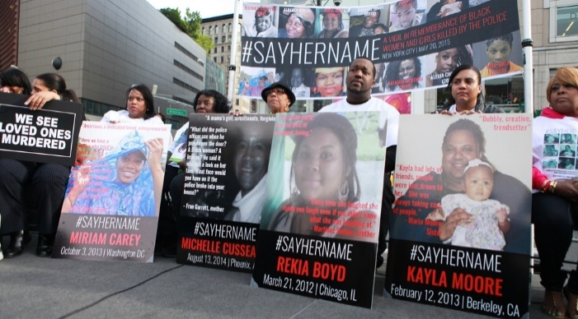
This project has two parts:
1)PowerPoint Presentation (Minimum 10 slides) (150 points)
AND
2) Reflection paper (2 page double spaced)(50 points)
200 points total!
For this project you will create a PowerPoint presentation that informs the audience about the #SayHerName Project AND the issue of police violence committed against Black Women.
In this PowerPoint you must include:
1) Information AND statistics about the violent victimization of women by the police
2) One specific woman’s case that you can find on the website (or another that you find that may not have been listed on this site). Be sure to describe the woman’s life, events surrounding her interactions with law enforcement (and sadly), her death, any other important information related to the case.
2) Suggestions on how to improve this situation and prevent violent victimization of Black women by police
GREAT resources to use!!!
https://aapf.org/sayhernamereport
https://aapf.org/sayhername
https://theconversation.com/a-short-history-of-black-women-and-police-violence-139937
https://scholarship.law.wm.edu/cgi/viewcontent.cgi?article=1462&context=wmjowl
You will be graded on the following:
-Essential Information about Case
-Information is Informative/Accurate
-Information is well-researched and referenced/cited appropriately

